Pakistan - Security situation

* 31ST OCTOBER 2019

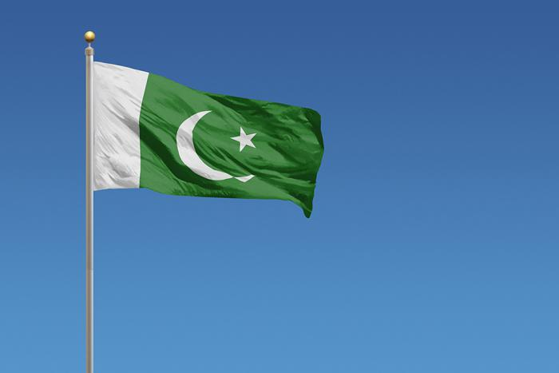

***Today, the European Asylum Support Office (EASO) published a Country of Origin Information (COI) Report entitled ‘***[***Pakistan security situation***](https://coi.easo.europa.eu/administration/easo/PLib/2019_EASO_Pakistan_Security_Situation_Report.pdf)***’. The report is the fourth update of the security chapter of the EASO COI report on Pakistan, Country Overview, published in August 20151 and subsequently updated in July 2016, August 2017 and October 2018.***

In 2018, the country ranked 4th in the top countries of origin in the EU+ countries,2 but the total number of Pakistani applicants decreased, from about 32 000 in 2017 to about 29 000 applications. By the end of 2018, the total number of pending cases at all instances decreased to some 44 000.

The EASO COI Report [Pakistan security situation](https://coi.easo.europa.eu/administration/easo/PLib/2019_EASO_Pakistan_Security_Situation_Report.pdf) provides a general description of the security situation in Pakistan, covering the following topics: an overview of recent conflicts in the country; actors in the conflict; an overview of recent security trends and armed confrontations; the impact of the violence on the civilian population; and the impact of the violence on the state ability to secure law and order.

The second part of the report provides an overview of the security situation in a more detailed description of the different regions in Pakistan. In each regional chapter, a short description is given of the region, the background of the violence as well as the actors present in the region, followed by a description of the security trends, and the impact of the violence on the population.

The report was drafted by the Belgian Office of the Commissioner General for Refugees and Persons (Cedoca, Centre for Documentation and Research) in accordance with the [EASO COI Report Methodology](https://coi.easo.europa.eu/administration/easo/PLib/2019_EASO_COI_Report_Methodology.pdf). It was reviewed by experts from Austria (Federal Office for Immigration and Asylum, Country of Origin Information Department), the Netherlands (Immigration and Naturalization Service, Office for Country Information and Language Analysis), Poland (Country of Origin Information Unit, Department for Refugee Procedures, Office for Foreigners), Sweden (Swedish Migration Agency, Section for Information Analysis), ACCORD (Austrian Centre for Country of Origin and Asylum Research and Documentation) and EASO, in order to ensure the highest quality.

It is EASO’s intention to continue to produce such reports on important countries of origin and to update them on a regular basis in order to raise and harmonise COI standards in the EU and to further support the practical implementation of the Common European Asylum System.

The report can be downloaded from [**here**](https://coi.easo.europa.eu/administration/easo/PLib/2019_EASO_Pakistan_security_situation.pdf).